Visualization Library Documentation

**Comprehensive Documentation Guide for Plotly and Bokeh:-**

This document provides a detailed exploration of two Python visualization libraries, Plotly and Bokeh, focusing on their capabilities for generating various graph types, practical examples, and a comparative analysis of their features. The content is designed to assist users in understanding and utilizing these libraries effectively, especially as of June 2025.

**Library Overviews**

**Plotly:-**

Plotly is an open-source Python library renowned for creating interactive, publication-quality visualizations. It supports over 40 unique chart types, including 2D, 3D, statistical, financial, geographic, scientific, and more, as detailed in its documentation

. Its high-level interface, Plotly Express, simplifies the creation of complex visualizations with minimal code, making it ideal for data exploration and dashboard creation. Plotly integrates seamlessly with Pandas and NumPy, offering extensive customization options for colors, styles, and interactivity, such as hover tools, zooming, and panning. It is particularly well-suited for building web-based applications through its Dash framework, which enhances its utility for data-driven storytelling and interactive dashboards.

Typical use cases include creating interactive dashboards for business analytics, visualizing complex datasets in scientific research, and developing web applications for data presentation. Its ability to handle large datasets with performance optimizations like WebGL rendering further enhances its applicability for modern data visualization needs.

**Bokeh:-**

Bokeh, another open-source Python library, focuses on creating interactive visualizations for modern web browsers, as outlined in its documentation . It is designed for high-performance interactivity over large or streaming datasets, making it ideal for exploratory data analysis and real-time data monitoring. Bokeh supports a variety of chart types, from basic line plots to advanced dashboards, and offers deep customization through its lower-level API. It provides server capabilities for building complex data applications, allowing for dynamic updates and interactivity through widgets and callbacks. Bokeh visualizations can be embedded in web pages, Jupyter notebooks, or standalone HTML files, enhancing its versatility for web development.

Typical use cases include exploratory data analysis with interactive tools, creating dashboards for real-time data monitoring, and building custom web applications with interactive visualizations. Its emphasis on performance with large datasets, supported by features like ColumnDataSource and WebGL, makes it a strong choice for data scientists and developers working with extensive data.

**Graph Types and Practical Examples:-**

Both Plotly and Bokeh support a wide array of graph types, including line plots, scatter plots, bar charts, histograms, and pie charts, among others. Below, we document five common graph types for each library, providing a brief description, potential use case, and a simple code example.

**Plotly Graph Types:-**

* **Line Plot**: A line plot displays data points connected by straight lines, useful for showing trends over a continuous variable, such as time series data.
  + **Use Case**: Visualizing stock prices over time.
  + **Code Example**:

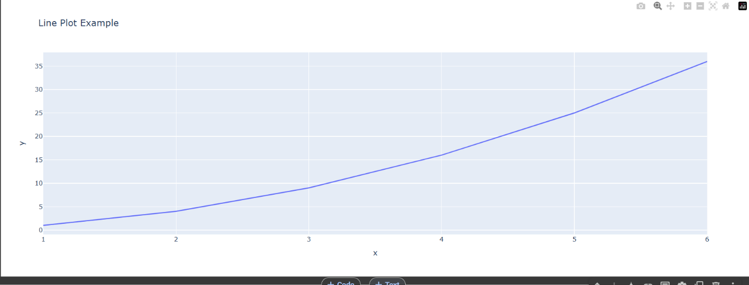

* **Scatter Plot**: A scatter plot displays individual data points as markers, ideal for showing relationships between two variables.
  + **Use Case**: Exploring correlations between variables, such as height vs. weight.
  + **Code Example**:

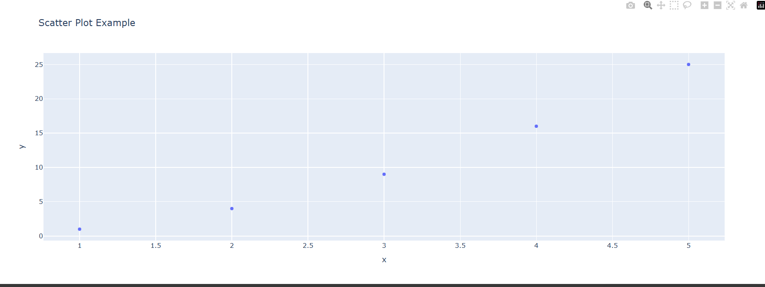

* **Bar Chart**: A bar chart represents categorical data with rectangular bars, useful for comparing quantities across categories.
  + **Use Case**: Comparing sales across different products or regions.
  + **Code Example**:

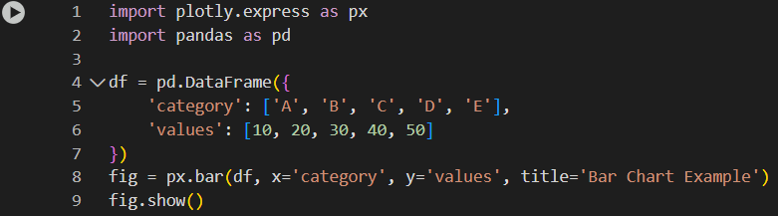

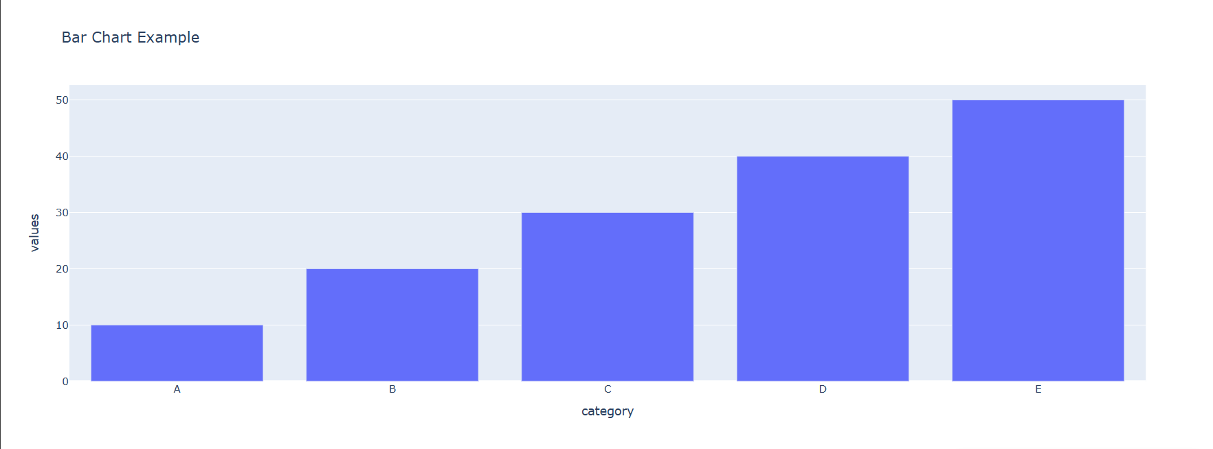

* **Histogram**: A histogram displays the distribution of a continuous variable by dividing it into bins, useful for analyzing frequency distributions.
  + **Use Case**: Analyzing the frequency distribution of exam scores.
  + **Code Example**:

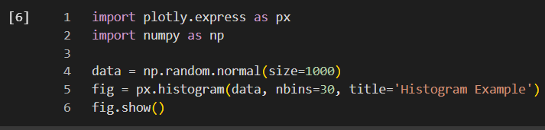

* **Pie Chart**: A pie chart shows proportions of a whole, with each slice representing a category’s contribution.
  + **Use Case**: Displaying market share or budget allocation.
  + **Code Example**:

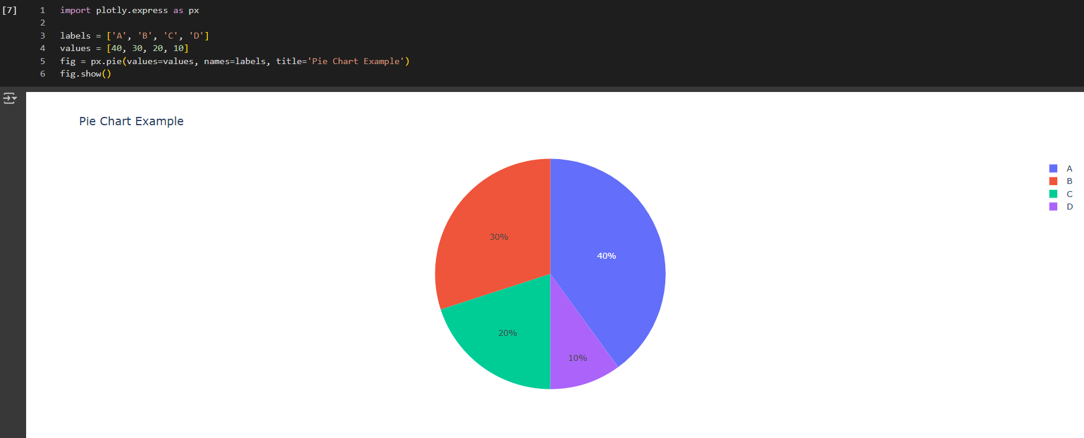

**Bokeh Graph Types:-**

* **Line Plot**: A line plot displays trends over time or continuous variables, with options for interactivity like zooming and panning.
  + **Use Case**: Visualizing temperature changes over time.
  + **Code Example**:

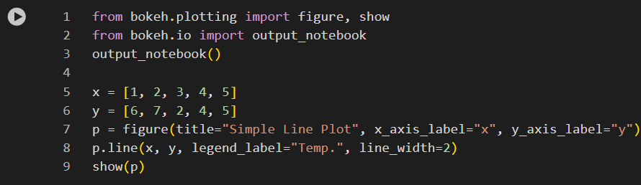

* **Scatter Plot**: A scatter plot shows relationships between two variables, with interactive features like hover tools for data inspection.
  + **Use Case**: Exploring correlations, such as height vs. weight.
  + **Code Example**:

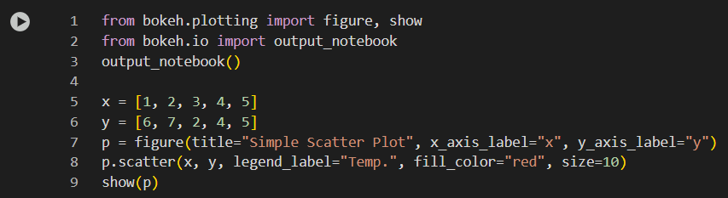

* **Bar Chart**: A bar chart compares quantities across categories, with options for vertical or horizontal bars and interactive legends.
  + **Use Case**: Comparing sales across products.
  + **Code Example**:

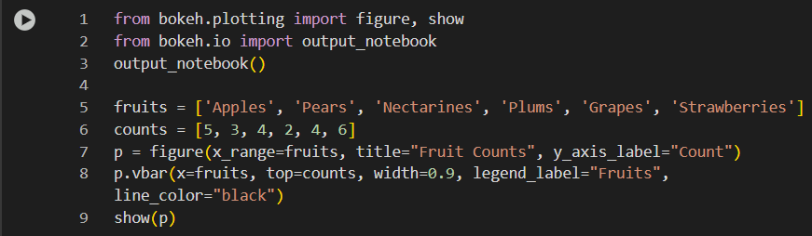

* **Histogram**: A histogram displays the distribution of a continuous variable, with bins for frequency analysis and interactive exploration.
  + **Use Case**: Analyzing frequency distributions, like customer ages.
  + **Code Example**:

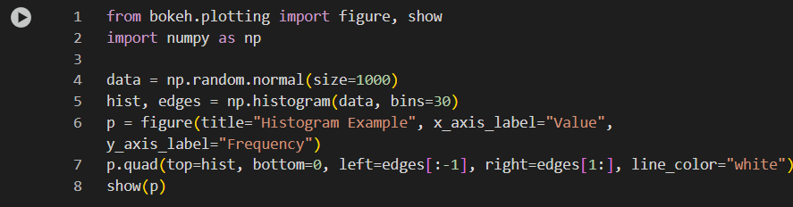

* **Pie Chart**: Bokeh creates pie charts using wedges, showing proportions with interactive hover tools for detailed insights.
  + **Use Case**: Displaying market share or budget allocation.
  + **Code Example**:

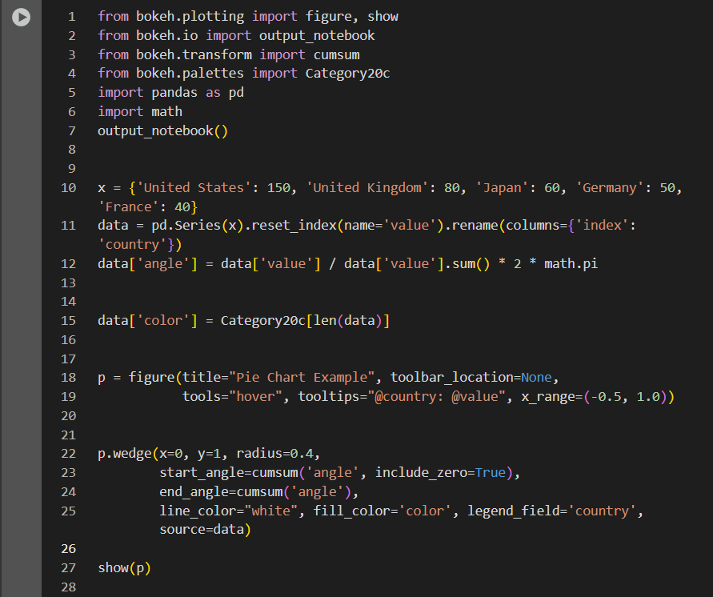

**Comparison Analysis:-**

To provide a structured comparison, we evaluate Plotly and Bokeh across four key dimensions: ease of use, customization options, interactivity, and performance with large datasets. The following table summarizes the findings:

| **Aspect** | **Plotly** | **Bokeh** |
| --- | --- | --- |
| **Ease of Use** | High, with Plotly Express for quick plotting; extensive examples and documentation make it beginner-friendly. | High, with quick tutorials and minimal examples; lower-level API may require more effort for advanced users. |
| **Customization Options** | High, with out-of-the-box options via Plotly Express and full API for deep control; supports extensive styling. | High, through lower-level API; offers deep customization but may require more manual work compared to Plotly. |
| **Interactivity** | Excellent, with hover tools, zooming, panning; Dash framework enhances dashboard creation for web applications. | Strong, with plot tools, widgets, and server capabilities; ideal for real-time, server-based applications. |
| **Performance with Large Datasets** | Handles large datasets well, using WebGL rendering and downsampling; supports streaming datasets with performance optimizations. | Designed for high-performance with large or streaming datasets, using ColumnDataSource and WebGL for efficiency. |

**Detailed Comparison:-**

* **Ease of Use**: Plotly’s Plotly Express module simplifies the creation of complex visualizations, making it accessible for users new to data visualization. Its extensive documentation, including tutorials and examples

may feel more complex for advanced customization due to its lower-level API, requiring more code for similar tasks.

* **Customization Options**: Both libraries offer high levels of customization, but Plotly provides more out-of-the-box options through Plotly Express, such as category orders and color maps, as seen in its styling controls , but users may need to manually adjust plot elements, which can be more time-consuming.
* **Interactivity**: Plotly excels in interactivity, with features like hover tools, zooming, and panning, and its Dash framework .
* **Performance with Large Datasets**: Plotly handles large datasets effectively, with performance optimizations like WebGL rendering, as discussed in community forums

, making it suitable for applications requiring real-time updates.

**Summary and Recommendations :-**

Plotly is likely the better choice for users seeking quick, interactive visualizations with minimal code, especially for dashboard creation and web applications, due to its Plotly Express module and extensive examples. Bokeh, however, is preferable for users needing high-performance interactivity with large datasets or building custom, server-based applications, given its lower-level API and server capabilities. The choice between the two depends on the specific use case, with Plotly excelling in ease of use and dashboard creation, and Bokeh shining in real-time, server-based applications.

**Key Citations:-**

* [Plotly Python Graphing Library](https://plotly.com/python/)
* [Bokeh Documentation](https://docs.bokeh.org/en/latest/)
* [First steps — Bokeh 3.7.3 Documentation](https://docs.bokeh.org/en/latest/docs/first_steps.html)
* [plotly.express in Python](https://plotly.com/python/plotly-express/)
* [user_guide/styling.html#ug-styling](https://docs.bokeh.org/en/latest/docs/user_guide/styling.html)
* [user_guide/interaction.html#ug-interaction](https://docs.bokeh.org/en/latest/docs/user_guide/interaction.html)
* [user_guide/server.html#ug-server](https://docs.bokeh.org/en/latest/docs/user_guide/server.html)
* [Proper way to plot large datasets - Dash Python - Plotly Community Forum](https://community.plotly.com/t/proper-way-to-plot-large-datasets/9793)
* [Accelerating with WebGL — Bokeh 2.4.3 Documentation](https://docs.bokeh.org/en/latest/docs/user_guide/webgl.html)
* [Dash](https://plotly.com/dash/)